ACT PEM Email System

Kevin Angus
November 2006

Overview 2
Technology 2
Components 2
Installation 2
Setup 2
XACT_PEM_EMAIL_TEMPLATES 3
System Options 3
Changing the Default Email Text 3
Use 4

Overview

The ACT PEM email system uses Document Manager to generate a document which is then attached to an email. Users can then edit the email before sending it.

Technology

The Form uses OLE, controlling Microsoft Word, to generate the document using the appropriate template. This document will reside in the location specified in DOC_LOCATIONS. In order to attach the file it is copied to a temporary area and read into the database using http. Other documents can be attached using a web page to upload them into the database. Once the email is ready it is sent by connecting to an SMTP server.

Components

The following components make up the enquiry email system:

XACT_PEM_EMAIL_TEMPLATES – table that stores the combinations of enquiry categories/classes/types that require emails.

XACT_PEM_EMAIL – package to support the enquiry email system.

XACT_PEM_EMAIL_WEB – package to generate and support the web pages in email system, specifically the add attachments page.

XDOC0010 – form used to edit and send the emails.

XDOCWEB0010 – web module that allows users to upload and attach files to the emails.

Installation

Run the file install_pem_email.sql as the Highways owner. This creates all the objects and data required.

An install log is created called install_pem_email.log which should be inspected to ensure there were no problems.

Copy the file xdoc0010.fmx to the Exor bin directory.

Setup

XACT_PEM_EMAIL_TEMPLATES

The table XACT_PEM_EMAIL_TEMPLATES is used to specify the kinds of enquiry that require an email and the destination address and template to be used in each case.

The table has the following structure:

Column | Type | NULL? | Notes
Xpet_category | Varchar2(4) | ✗ | Category of the enquiry. From DOC_TYPES.
Xpet_class | Varchar2(4) | ✗ | Class of the enquiry. From DOC_CLASS.
Xpet_type | Varchar2(4) | ✗ | Type of the enquiry. From DOC_ENQUIRY_TYPES
Xpet_ne_id | Number(9) | ✗ | The ne_id of the location.
Xpet_nmu_id | Number(9) | ✗ | The email destination. Mail user ID from NM_MAIL_USERS.
Xpet_dtg_template_name | Varchar2(30) | ✗ | The template to use to generate the document. From DOC_TEMPLATE_GATEWAYS

System Options

XDOCTMPDIR – this is the directory that the Forms will copy the generated documents to so they can be read by the database e.g. \\mac040\D\documents

XDOCTMPURL – this is the URL that the database will use to read the generated documents in order to attach them to the emails. In the configuration of the web server this will point to the same location as that referred to by XDOCTMPDIR E.g. http://mac040:81/documents/

XDEFRPLADD – this is the general reply to address used when sending enquiry emails e.g. iamsreplies@act.gov.au

The email options (SMTP%) should be also be set as appropriate.

Changing the Default Email Text

The text of the email message can be modified. It is stored in a constant (c_email_text) in the xact_pem_email package header. It can be any text and if the enquiry details are required then include the marker <enq_details>. An example of this can be seen in the package as supplied.

Use

Run the module XDOC0010, Enquiry Emails.

Select an enquiry from the List of Values. The LOV will display enquiries that are set to status “Send Email” and that match the criteria defined in the table XACT_PEM_EMAIL_TEMPLATES.

Once an enquiry has been chosen, click Create Email.

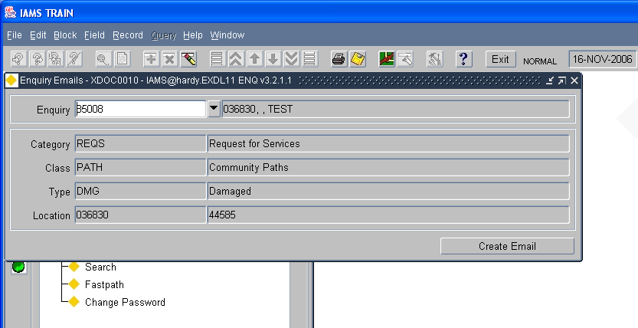

At this point Document Manager creates the document using the appropriate template.

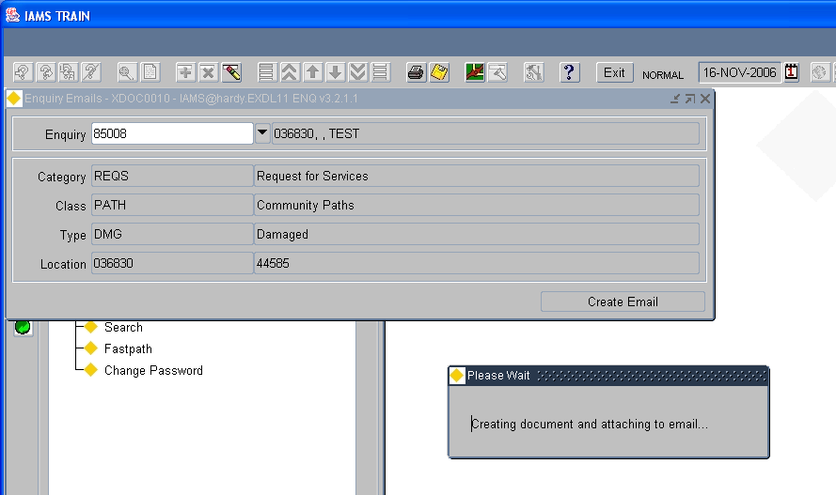

Once the document has been created the email is displayed showing it as an attachment. The email details can be edited as necessary. More than one recipient addresses can be entered as long as they are separated by a comma or a semi-colon.

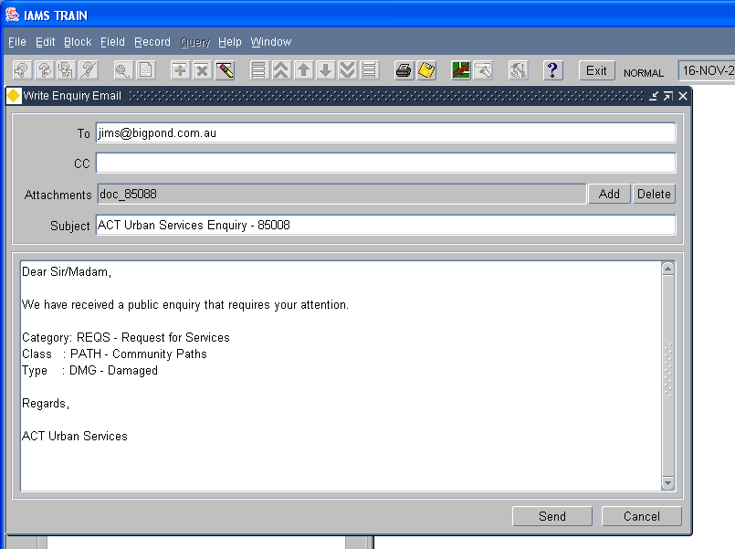

To add an extra attachments click the Add button. This opens a web page to allow the user to upload the file or files.

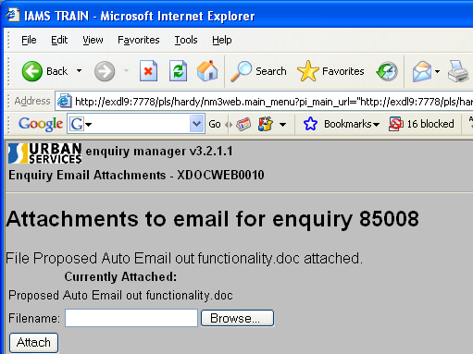

Once all the files have been uploaded then the web page can be closed. On returning to Forms, click the OK button to continue.

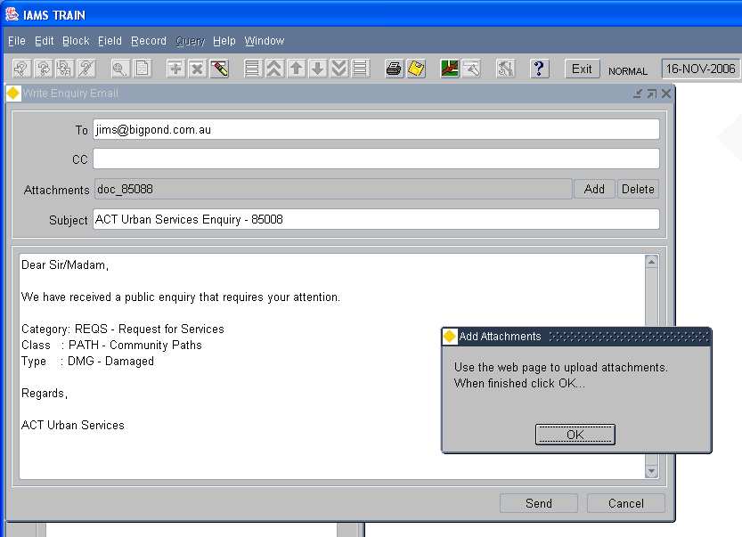

The attachments list will be updated to reflect the files loaded.

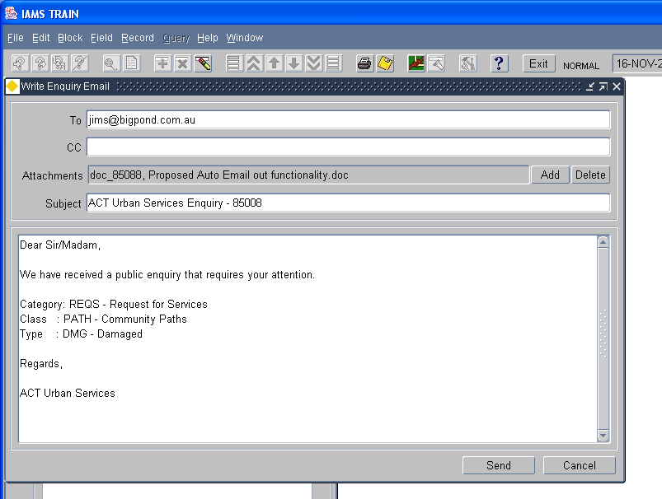

To Remove an attached file, click Delete. This brings up a list of the files which can then be removed. Once finished click Done.

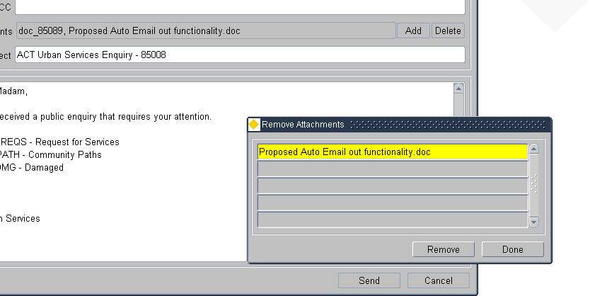

Finally, click “Send” to send the email.

